Harlinsdale Farms Tour, Saturday September 20, 2008

NINTH CAVALRY One Hundred and Twenty-first Regiment, Indiana Volunteers
Action near Franklin, December 17, 1864
“… Debouching into the open near Franklin, the cannon from the fort opened on us with shell. The head of the column turned to the right a short distance and wheeled into line – the center and left coming on ‘front into line.’ Hammond being at the head of the column gave the command to charge before the line was barely formed. The right sprang forward at the command and was rapidly followed by the center. The left, under Captain Hobson, was not yet in line and did not hear the command. Hammond again shouted ‘charge!’ Hobson was looking after the alignment and did not hear the command. Hammond galloped to him and said: ‘You cowardly son of a bitch! Why don’t you charge?’ Hobson raised himself in the stirrups and said: ‘Boys, we will show who are the cowards!’ Forward! Trot! Charge!’ and lead the boys right up to the fort, where he was shot through the heart. … The Confederates had torn down the telegraph wire and, driving posts at intervals, had encircled the fort with it. This was unseen by the assaulting party until their horses tumbled over it. Encumbered by the horses who were useless in attacking the fort, impeded by a stone wall and wire fence, under an awful fire of grape and canister and musketry at short range, the regiment fell back in disorder, but not without bringing off two stands of colors and over two hundred prisoners. … Falling back perhaps two hundred yards from the fort and partially sheltered from the shells and musket balls by a slight depression in the plain, acting Adjutant Comstock, under orders from the Colonel, planted the regimental colors, and the line was soon formed again. This was done quickly and well under fire. The shells were passing overhead and bursting threw the fragments among the men in a most distressingly familiar way. Lieut. Burroughs, of Company C, had been disabled in the charge, and, as the men from the left were crossing the pike to form on the colors, he asked for assistance to remount his horse, which was standing near. Two men tried to assist him, but just then a fragment from a bursting shell tore away half his skull. He was carried to the rear in a dying condition. … The charge was unwisely ordered, but bravely and brilliantly executed. To ride down in the face of a withering fire on a fort inaccessible to cavalry, defended by artillery and infantry, greatly outnumbering the attacking force, was apparently a ride to death. That it was not so we must thank Him without whose notice no sparrow falls to the ground. No one faltered; none turned back until all that could be done was accomplished. Bravely as this was done, it did not show forth that true courage, born of moral worth and a high sense of duty, as did the prompt rallying of the broken companies, and the speedy reforming of the line, under fire, and the patient waiting for orders among the bursting shells. This was the true touchstone of our greatness as a regiment, and nobly did the boys stand the test.”
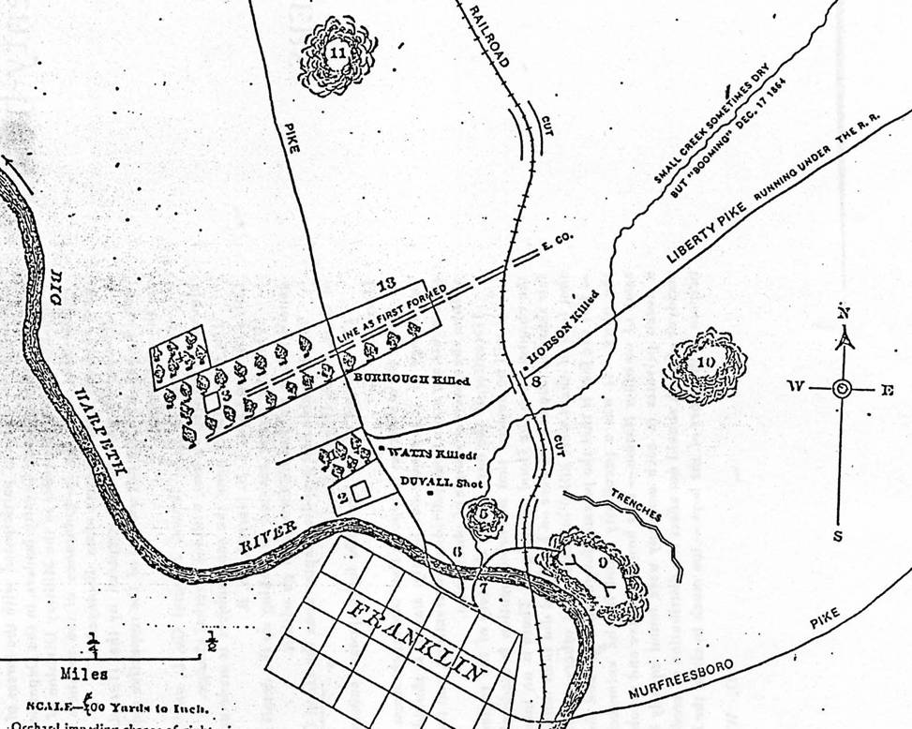

1. Orchard impeding charge of right wing.
2. Rozell dwelling, grove and shrubbery concealing sharpshooters who killed Watts.
3. Manny’s dwelling and grove.
4. Manny’s orchard
5. Fort defended by artillery and muskets.
6 and 7. Pontoon roads
8. Bridge on railroad, under which Hobson was killed.
9. Fort Granger; not occupied
10. Fort; not occupied
11. Fort; not occupied.
12. Fort Roper knob; not occupied.
13. Fruit nursery and grove (Line reformed near position of first line, in a depression, sheltered from shell which passed overhead.)

